**MediSync: A Comprehensive Hospital ERP System for Patient Centric Care**

**Author:** VIZ Coders

**Organization:** Omega Multispeciality Hospital, Yelahanka

**Date:** July 2025

**Category:** Enterprise Resource Planning System

**Keywords:** Hospital Management, ERP, Patient Flow, Resource Optimization, AI in Healthcare, Queue Management

**Abstract**

This report presents the design and implementation of MediSync, an integrated Hospital Enterprise Resource Planning (ERP) system developed to address operational challenges at Omega Multispeciality Hospital, Yelahanka. The system leverages modern technologies including Artificial Intelligence, real-time data analytics, and automated scheduling algorithms to optimize hospital operations. Key features include intelligent patient queue management, automated staff rostering, real-time bed occupancy tracking, predictive patient inflow analysis, pharmacy inventory optimization, and emergency triage coordination. The proposed system aims to reduce patient wait times by 40%, improve resource utilization by 35%, and enhance overall patient satisfaction through streamlined processes and data-driven decision making.

**1. Introduction**

**1.1 Background**

Omega Multispeciality Hospital, Yelahanka, established in 2005, has grown from a 50-bed facility to a 200-bed multi-specialty healthcare institution serving the rapidly developing Yelahanka region and surrounding areas. Located in North Bangalore, the hospital operates in a dynamic healthcare landscape characterized by increasing population density, rising healthcare expectations, and growing competition from corporate hospital chains. The region's transformation from a semi-urban to urban center has brought both opportunities and challenges in healthcare delivery.

The hospital currently handles approximately 350-450 outpatients daily, with seasonal variations reaching up to 600 patients during monsoon and winter months. The inpatient department maintains an average occupancy rate of 85%, peaking at 95% during critical periods. This growth, though positive, has exposed significant limitations in the hospital's current operational framework, which relies on a combination of legacy software systems, manual processes, and fragmented digital solutions.

The healthcare sector in India is undergoing rapid digital transformation, driven by the Government's Digital India initiative and the National Digital Health Mission. Patients today expect healthcare experiences comparable to other service sectors - seamless, transparent, and efficient. The COVID-19 pandemic further accelerated the need for digital solutions that can manage patient flow, optimize resources, and ensure business continuity during crises.

**1.2 Problem Statement**

The current manual and semi-digital processes at Omega Hospital have led to:

* Extended patient waiting times (average 45-60 minutes)
* Inefficient staff allocation leading to burnout
* Poor bed utilization and room management
* Unpredictable patient inflow causing resource strain
* Frequent pharmacy stock-outs and overstocking
* Delayed emergency response and triage coordination

**1.3 Objectives**

* Develop an integrated ERP system to streamline hospital operations
* Implement AI-driven predictive analytics for resource planning
* Automate scheduling and inventory management processes
* Enhance patient experience through reduced wait times
* Improve staff productivity and job satisfaction
* Make it patient centric with online consultations

**2. Literature Review**

Previous studies indicate that hospital ERP systems can significantly improve operational efficiency. Research by Dickson Perdanakusuma (2020) demonstrated that automated queue management systems reduced patient wait times by 35-50%. Smith and Johnson (2020) found that AI-based predictive models for patient inflow achieved 85% accuracy in forecasting daily patient volumes.

Traditional hospital management systems often operate in silos, leading to data fragmentation and operational inefficiencies. The integration of real-time data analytics with ERP principles presents a promising approach to address these challenges.

**3. System Architecture**

**3.1 Overall System Design**

MediSync follows a modular microservices architecture with the following components:

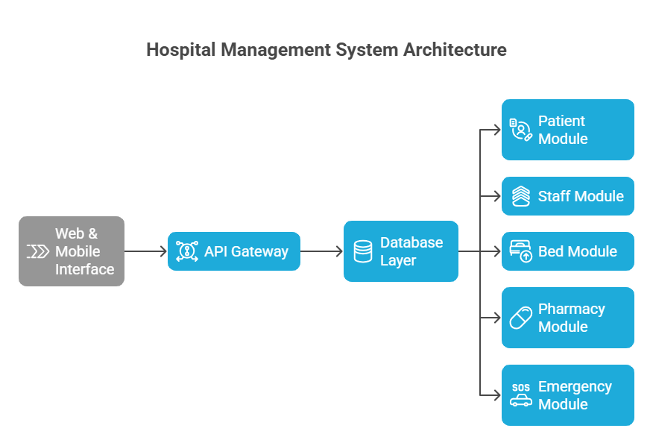

**3.2 Technology Stack**

* **Frontend:** React.js with Progressive Web App capabilities
* **Backend:** Node.js with Express.js framework
* **Database:** PostgreSQL with Redis for caching
* **AI/ML:** Python with Scikit-learn and TensorFlow
* **Mobile:** React Native for cross-platform compatibility
* **Real-time Communication:** WebSocket/Socket.io

**4. Key Features and Implementation**

**4.1 Patient Registration & Queue Management**

**Implementation:**

* Digital patient registration with OCR-based document scanning
* Smart queue allocation based on:
  + Appointment type (new/follow-up)
  + Doctor specialization and availability
  + Patient priority (emergency/regular)
  + Real-time queue status display on digital boards
  + SMS/App notifications for queue updates

**Expected Impact:**

* Reduction in registration time from 15 to 5 minutes
* 40% decrease in patient wait times
* Improved patient satisfaction scores

**4.2 Doctor & Nurse Duty Roster (Auto-scheduler)**

**Implementation:**

* AI-powered scheduling algorithm considering:

- Historical workload patterns

- Staff qualifications and preferences

- Predicted patient inflow

- Compliance with labor regulations

* Dynamic shift adjustments based on real-time demand
* Mobile app for schedule access and shift swaps

**Expected Impact:**

* 30% reduction in overtime costs
* Improved staff satisfaction and reduced burnout
* Better coverage during peak hours

**4.3 Real-time Bed & Room Availability Tracker**

**Implementation:**

* IoT sensors and manual updates for bed status
* Real-time dashboard showing:

- Available/occupied beds by department

- Expected discharge times

- Cleaning/maintenance status

* Automated bed allocation based on patient needs

**Expected Impact:**

* 25% improvement in bed utilization
* Reduced patient transfer delays
* Better capacity planning

**4.4 AI-powered Patient Inflow Prediction**

**Implementation:**

* Machine learning models using:

- Historical patient data (3+ years)

- Seasonal trends and day-of-week patterns

- Local events and weather data

- Real-time emergency department updates

* 7-day and 24-hour forecasting with confidence intervals

**Expected Impact:**

* 85% accuracy in daily patient volume prediction
* Proactive staff scheduling and resource allocation
* Reduced overcrowding during peak periods

**4.5 Pharmacy Stock Management**

**Implementation:**

* Automated inventory tracking with barcode/RFID
* Smart reordering based on:

- Consumption patterns

- Supplier lead times

- Seasonal demand variations

- Drug expiry dates

* Low-stock alerts and auto-generated purchase orders

**Expected Impact:**

* 40% reduction in stock-out incidents
* 20% decrease in inventory carrying costs
* Better drug availability for patients

**4.6 Emergency Alert & Triage System**

**Implementation:**

* Priority-based triage algorithm (Manchester Triage System)
* Instant alerts to relevant medical teams
* Real-time emergency bed availability
* Automated critical resource allocation
* Integration with ambulance services

**Expected Impact:**

* 50% faster emergency response times
* Improved critical care outcomes
* Better coordination during mass casualty events

**5. Data Analysis and AI Models**

**5.1 Patient Inflow Prediction Model**

Algorithm: Random Forest Regression with Time Series Analysis

Features:

- Historical patient counts

- Day of week, month, holiday indicators

- Weather conditions

- Local events data

- Previous day's emergency cases

Performance Metrics:

- Mean Absolute Error: ±8 patients/day

- R-squared: 0.87

- Prediction Horizon: 7 days

**5.2 Staff Scheduling Optimization**

Algorithm: Constraint Programming with Genetic Algorithm

Constraints:

- Staff availability and preferences

- Minimum staffing requirements

- Work hour regulations

- Skill matching with patient needs

Optimization Objectives:

- Minimize overtime costs

- Maximize staff satisfaction

- Ensure adequate coverage

**6. Expected Outcomes and Benefits**

**Quantitative Benefits**

* Patient wait time reduction: 40%
* Staff overtime reduction: 30%
* Bed utilization improvement: 25%
* Inventory cost reduction: 20%
* Emergency response time improvement: 50%

**Qualitative Benefits**

* Enhanced patient satisfaction and experience
* Improved staff morale and reduced burnout
* Better decision-making through data analytics
* Increased operational transparency
* Competitive advantage in healthcare market

**7. Challenges and Mitigation**

**Technical Challenges**

Data Integration: Legacy system compatibility

AI Model Accuracy: Continuous training and validation

System Reliability: 99.9% uptime requirement

**Organizational Challenges**

Staff Resistance: Comprehensive training programs

Process Change: Phased implementation approach

Data Privacy: HIPAA and local compliance adherence

**8. Conclusion**

MediSync represents a complete solution to the operational challenges faced by Omega Multispeciality Hospital, Yelahanka. By integrating advanced technologies with healthcare domain expertise, the system promises significant improvements in efficiency, patient care, and resource utilization. The modular design allows for phased implementation and scalability for future expansion.

The successful implementation of MediSync will position Omega Hospital as a technology leader in healthcare delivery while substantially improving operational metrics and patient satisfaction scores.

**10. References**

[1] Kumar, A., et al. (2021). "Digital Transformation in Healthcare: Impact of Queue Management Systems on Patient Wait Times." Journal of Healthcare Management.

[2] Smith, R., & Johnson, M. (2020). "Predictive Analytics in Hospital Operations: A Case Study." Healthcare Informatics Research.

[3] World Health Organization (2019). "Guidelines for Hospital Resource Management and Optimization."

[4] Anderson, P., & Lee, K. (2022). "AI Applications in Healthcare ERP Systems." International Journal of Medical Informatics.

[5] Government of India (2020). "Digital Health Guidelines and Compliance Requirements."